

**NAME: Muhammad Ali Khan, Muhammad Waleed, Murtaza Kazmi**

**SECTION: B**

**ROLL NO: i210429, i210438, i210685**

**BATCH ID: BSCS-2021**

**WORK: Software Engineering-Iteration 0**

**TITLE OF PROJECT:**

FINAL YEAR PROJECT MANAGEMENT SYSTEM

**PROBLEM / STATEMENT:**

|  |  |
| --- | --- |
| **The Problem of** | Inefficient Management of Final Year Projects (FYPs) |
| **Affects** | undergraduate students, faculty supervisors, and FYP Committee members involved in the FYP management process |
| **The impact of which is** | hindering the efficiency, transparency, and collaboration in the FYP lifecycle. Manual processes for tasks such as student registration, supervisor assignment, panel creation, evaluation submission, and result generation are time-consuming, error-prone, and lack efficient communication channels. Additionally, the absence of a centralized system leads to difficulties in workload management, deadline tracking, and audit trail maintenance. |
| **A successful solution would be** | the development and implementation of a comprehensive web-based Final Year Project Management System (FYPMS) that automates tasks, improves communication channels, and ensures secure access control. By streamlining the entire FYP lifecycle, the FYPMS aims to enhance collaboration among stakeholders, optimize workload distribution, facilitate timely evaluation submissions, and provide robust security measures and audit trail capabilities. |

**LIST OF FEATURES: (OpenEMR Format)**

1. **User Registration and Authentication**

* Allow users to register with the system.
* Authenticate users with login credentials.

1. **Role-Based Access Control**

* Define roles such as FYP Committee, Panel Members, Project Supervisors, and Students.
* Assign specific privileges to each role based on their responsibilities.

1. **Student Group Creation for FYPs**

* Enable students to create groups for their FYPs.
* Specify group details including project title, description, and member information.

1. **Supervisor Assignment to Student Groups**

* Assign supervisors to student groups based on availability and expertise.
* Limit the number of FYPs each supervisor can oversee.

1. **Panel Creation by FYP Committee**

* Allow FYP Committee members to create evaluation panels.
* Specify panel details including members and assigned FYPs.

1. **Evaluation Form Creation for Panel Members**

* Enable FYP Committee to create evaluation forms for panel members.
* Define assessment criteria and scoring mechanisms.

1. **Deadline Management for Submissions and Evaluations**

* Set deadlines for project submissions, evaluations, and presentations.
* Send automated notifications and reminders to stakeholders.

1. **Notifications and Reminders for Deadlines**

* Notify users of approaching deadlines via email or in-app notifications.
* Allow users to customize notification preferences.

1. **Group Member Management**

* Allow group leaders to manage group membership (add/remove members).
* Ensure accurate representation of group composition.

1. **Project Title and Description Management**

* Enable students to update project title and description as needed.
* Provide a centralized repository for project information.

1. **Supervisors' Workload Management**

* Monitor the number of FYPs assigned to each supervisor.
* Automatically redistribute FYPs to balance workload.

1. **Evaluation Submission by Panel Members**

* Allow panel members to submit evaluations for assigned FYPs.
* Provide a user-friendly interface for assessment entry.

1. **Review and Feedback Submission by Supervisors**

* Enable supervisors to provide feedback and reviews on student projects.
* Facilitate constructive criticism and suggestions for improvement.

1. **Tracking Missing Evaluations and Submissions**

* Identify and track incomplete evaluations and submissions.
* Provide alerts to stakeholders for follow-up actions.

1. **Generating Reports on Missing Evaluations**

* Generate reports listing FYPs with missing evaluations.
* Facilitate prompt resolution of outstanding tasks.

1. **Generating Reports on FYPs Supervised by Faculty**

* Provide reports detailing FYPs supervised by each faculty member.
* Include workload count and project details.

1. **Generating Reports on Grades Statistics**

* Generate statistical reports on student grades.
* Analyze distribution of grades and faculty grading patterns.

1. **Viewing Project Details by Students**

* Allow students to view details of their assigned projects.
* Provide access to project title, description, supervisor, and group members.

1. **Viewing Assigned Panels by Students**

* Enable students to view the evaluation panels assigned to their projects.
* Access panel member information for transparency.

1. **Viewing Evaluation Comments and Feedback by Students**

* Provide students with access to evaluation comments and feedback.
* Foster continuous improvement and learning.

1. **Viewing Deadlines for Submissions and Presentations by Students**

* Display deadlines for project submissions and presentations.
* Ensure students are aware of key milestones and timelines.

1. **Viewing Grades of FYPs by Students**

* Allow students to view grades and evaluations for their projects.
* Provide transparency in assessment outcomes.

1. **Audit Trail for Tracking User Actions**

* Log user actions and system activities for auditing purposes.
* Maintain a record of user interactions and changes made to data.

1. **Secure Data Encryption for Sensitive Information**

* Encrypt sensitive data such as passwords and personal information.
* Ensure confidentiality and data security.

1. **Admin Interface for Managing System Settings and Configurations**

* Provide administrators with access to system settings.
* Allow configuration of user roles, permissions, and system preferences.

1. **User Profile Management**

* Enable users to manage their profiles (update password, email, etc.).
* Ensure user information is up-to-date and accurate.

1. **Search Functionality for Finding Specific Projects or Users**

* Implement search functionality to locate specific projects or users.
* Enhance usability and accessibility of system data.

1. **Exporting Reports to PDF or Excel Formats**

* Allow users to export reports to PDF or Excel formats.
* Facilitate data analysis and sharing.

1. **Mobile Responsiveness for Access on Different Devices**

* Ensure the system is responsive and accessible on mobile devices.
* Allow users to access features and functionalities on the go.

1. **Help and Support Documentation for Users**

* Provide comprehensive documentation and user guides.
* Assist users in navigating the system and understanding its features.

**USER STORIES: (Product Backlog)**

**Story ID: 1 Story Title: User Registration and Authentication**

**Medium**

**Core functionality**

**High**

**Importance:**

**Estimate:**

**Type:**

**User Story:**

**Acceptance Criteria:**

Given that I am on the registration page,

* When I provide valid registration details,
* Then my account should be created successfully.

Given that I am a registered user,

* When I log in with correct credentials,
* Then I should be authenticated and granted access to the system.

Given that I provide incorrect login credentials,

* When I attempt to log in,
* Then I should receive an error message indicating invalid credentials.
* As a new user,
* I want to register for an account and authenticate myself,
* So that I can access the system and perform tasks related to my role.

**Story ID: 2 Story Title: Role-Based Access Control**

**High**

**Core functionality**

**High**

**Importance:**

**Estimate:**

**Type:**

User Story:

Acceptance Criteria:

Given that I am an administrator,

* When I assign a role to a user,
* Then the user should have access to functionalities specific to that role.

Given that I am a user with a specific role,

* When I log in,
* Then I should only see options and features corresponding to my role.

Given that I am an unauthorized user trying to access restricted functionality,

* When I attempt to access it,
* Then I should be denied access and prompted to request appropriate permissions.
* As a system administrator,
* I want to assign roles and permissions to users,
* So that users can only access functionalities relevant to their roles.

**Story ID: 3 Story Title: Student Group Creation for FYPs**

**Medium**

**Core functionality**

**High**

**Importance:**

**Estimate:**

**Type:**

**User Story:**

**Acceptance Criteria:**

Given that I am a student logged into the system,

* When I navigate to the group creation page,
* Then I should be able to create a new group by providing necessary details.

Given that I have created a group,

* When I invite other students to join,
* Then they should receive invitations and be able to join the group.

Given that I am a student without a group,

* When I search for existing groups to join,
* Then I should be able to request to join a group.
* As a student,
* I want to create a group for my Final Year Project,
* So that I can collaborate with my peers on the project.

**Story ID: 4 Story Title: Supervisor Assignment to Student Groups**

**Medium**

**Core functionality**

**High**

**Importance:**

**Estimate:**

**Type:**

**User Story:**

**Acceptance Criteria:**

Given that I am a FYP Committee member,

* When I review student group details and available supervisors,
* Then I should be able to assign a supervisor to each group.

Given that a supervisor has been assigned to a group,

* When students view their group details,
* Then they should see the assigned supervisor's information.

Given that a supervisor has reached their maximum workload,

* When I attempt to assign them to another group,
* Then I should receive a notification indicating the workload limit has been reached.
* As a FYP Committee member,
* I want to assign supervisors to student groups,
* So that each group has appropriate guidance and mentorship.

**Story ID: 5 Story Title: Panel Creation by FYP Committee**

**Medium**

**Core functionality**

**High**

**Importance:**

**Estimate:**

**Type:**

**User Story:**

**Acceptance Criteria:**

Given that I am a FYP Committee member,

* When I navigate to the panel creation page,
* Then I should be able to create a new panel and assign faculty members to it.

Given that I have created a panel,

* When I assign projects to it for evaluation,
* Then faculty members assigned to the panel should be notified.

Given that a panel is created,

* When a faculty member logs in,
* Then they should see the projects assigned to their panel for evaluation.
* As a FYP Committee member,
* I want to create evaluation panels for FYPs,
* So that projects can be assessed by faculty members.

**Story ID: 6 Story Title: Evaluation Form Creation for Panel Members**

**Medium**

**Core functionality**

**High**

**Importance:**

**Estimate:**

**Type:**

**User Story:**

**Acceptance Criteria:**

Given that I am a FYP Committee member,

* When I navigate to the evaluation form creation page,
* Then I should be able to define assessment criteria and rating scales.

Given that an evaluation form is created,

* When a panel member accesses it for evaluation,
* Then they should be able to provide ratings and feedback for each criterion.

Given that an evaluation is submitted by a panel member,

* When I review the evaluation form,
* Then I should see the ratings and feedback provided by the panel member.
* As a FYP Committee member,
* I want to create evaluation forms for panel members,
* So that standardized assessments can be conducted for FYPs.

**Story ID: 7 Story Title: Deadline Management for Submissions and Evaluations**

**Medium**

**Core functionality**

**High**

**Importance:**

**Estimate:**

**Type:**

**User Story:**

**Acceptance Criteria:**

Given that I am a FYP Committee member,

* When I navigate to the deadline management page,
* Then I should be able to set deadlines for project submissions and evaluations.

Given that deadlines are set,

* When students and panel members log in,
* Then they should see the deadlines for their respective tasks prominently displayed.

Given that a deadline has passed,

* When a task is not completed,
* Then stakeholders should be notified of the overdue task.
* As a FYP Committee member,
* I want to set deadlines for project submissions and evaluations,
* So that tasks are completed within specified timeframes.

**Story ID: 8 Story Title: Notifications and Reminders for Deadlines**

**Medium**

**Core functionality**

**High**

**Importance:**

**Estimate:**

**Type:**

**User Story:**

**Acceptance Criteria:**

* Given that deadlines are approaching,
* When the system detects upcoming deadlines,
* Then notifications should be sent to relevant stakeholders via email or within the system.

Given that a notification is received,

* When a stakeholder views it,
* Then they should have the option to acknowledge the notification or snooze it for later.
* As a system,
* I want to send notifications and reminders for upcoming deadlines,
* So that stakeholders are informed and tasks are completed on time.

**Story ID: 9 Story Title: Group Member Management**

**Medium**

**Core functionality**

**High**

**Importance:**

**Estimate:**

**Type:**

**User Story:**

**Acceptance Criteria:**

Given that I am a student logged into the system,

* When I navigate to the group management page,
* Then I should be able to add or remove members from my group.

Given that a member is added or removed,

* When group details are updated,
* Then all members should be notified of the change.
* As a student,
* I want to manage group membership for my FYP,
* So that I can collaborate effectively with my team members.

**Story ID: 10 Story Title: Project Title and Description Management**

**Low**

**Core functionality**

**High**

**Importance:**

**Estimate:**

**Type:**

**User Story:**

**Acceptance Criteria:**

Given that I am a student logged into the system,

* When I navigate to the project details page,
* Then I should be able to edit the title and description of my project.

Given that project details are updated,

* When faculty members or panel members access the project details,
* Then they should see the latest information provided by the student.
* As a student,
* I want to manage the title and description of my FYP,
* So that I can provide clear information about my project.

**Story ID: 11 Story Title: Supervisors' Workload Management**

**Medium**

**Core functionality**

**High**

**Importance:**

**Estimate:**

**Type:**

**User Story:**

**Acceptance Criteria:**

Given that I am a FYP Committee member,

* When I review the workload of supervisors,
* Then I should be able to see the number of FYPs assigned to each supervisor.

Given that a supervisor's workload exceeds the maximum limit,

* When I redistribute FYPs among supervisors,
* Then the workload should be balanced accordingly.

Given that FYPs are reassigned to different supervisors,

* When affected students log in,
* Then they should see the updated supervisor information for their project.
* As a FYP Committee member,
* I want to monitor and manage the workload of supervisors,
* So that each supervisor has a manageable number of FYPs to oversee.

**Story ID: 12 Story Title: Evaluation Submission by Panel Members**

**Medium**

**Core functionality**

**High**

**Importance:**

**Estimate:**

**Type:**

**User Story:**

**Acceptance Criteria:**

Given that I am a panel member,

* When I access the evaluation form for an assigned FYP,
* Then I should be able to provide ratings and feedback for each criterion.

Given that I submit an evaluation,

* When the evaluation form is submitted,
* Then the ratings and feedback should be recorded for further processing.

Given that an evaluation form is submitted by a panel member,

* When I review the submitted evaluations,
* Then I should see the ratings and feedback provided for each FYP.
* As a panel member,
* I want to submit evaluations for assigned FYPs,
* So that projects can be assessed and graded effectively.

**Story ID: 13 Story Title: Review and Feedback Submission by Supervisors**

**Medium**

**Core functionality**

**High**

**Importance:**

**Estimate:**

**Type:**

**User Story:**

**Acceptance Criteria:**

Given that I am a supervisor,

* When I access the FYP details assigned to me,
* Then I should be able to review the project documentation and progress.

Given that I review a project,

* When I provide feedback,
* Then the feedback should be recorded and accessible to the student.

Given that feedback is provided,

* When a student accesses their project details,
* Then they should see the feedback provided by the supervisor.
* As a supervisor,
* I want to review and provide feedback on FYPs assigned to me,
* So that students can improve their projects based on my input.

**Story ID: 14 Story Title: Tracking Missing Evaluations and Submissions**

**Medium**

**Core functionality**

**High**

**Importance:**

**Estimate:**

**Type:**

**User Story:**

**Acceptance Criteria:**

Given that I am a FYP Committee member,

* When I view the evaluation status dashboard,
* Then I should be able to see which evaluations are missing for each FYP.

Given that evaluations are missing,

* When I select a specific FYP,
* Then I should see a list of panel members who have not submitted their evaluations.

Given that evaluations are overdue,

* When a notification is triggered,
* Then stakeholders should be informed of the overdue evaluations.
* As a FYP Committee member,
* I want to track missing evaluations and submissions,
* So that necessary actions can be taken to ensure completion.

**Story ID: 15 Story Title: Generating Reports on Missing Evaluations**

**High**

**Reporting**

**High**

**Importance:**

**Estimate:**

**Type:**

**User Story:**

**Acceptance Criteria:**

Given that I am a FYP Committee member,

* When I select the "Missing Evaluations" report option,
* Then I should be able to generate a report listing all FYPs with missing evaluations.

Given that a report is generated,

* When I review the report,
* Then I should see details of each FYP along with the panel members who have not submitted evaluations.

Given that I identify missing evaluations,

* When I take action to follow up,
* Then I should be able to track the progress of resolution.
* As a FYP Committee member,
* I want to generate reports on missing evaluations,
* So that I can take appropriate actions to address the issue.

**Story ID: 16 Story Title: Generating Reports on FYPs Supervised by Faculty**

**High**

**Reporting**

**High**

**Importance:**

**Estimate:**

**Type:**

**User Story:**

**Acceptance Criteria:**

Given that I am a FYP Committee member,

* When I select the "FYPs Supervised by Faculty" report option,
* Then I should be able to generate a report listing all faculty members and the FYPs assigned to each.

Given that a report is generated,

* When I review the report,
* Then I should see details of each faculty member along with the FYPs supervised by them.

Given that I analyze the workload,

* When I identify an imbalance,
* Then I should be able to reassign FYPs to balance the workload.
* As a FYP Committee member,
* I want to generate reports on FYPs supervised by faculty,
* So that I can monitor workload distribution and progress.

**Story ID: 17 Story Title: Generating Reports on Grades Statistics**

**High**

**Reporting**

**High**

**Importance:**

**Estimate:**

**Type:**

**User Story:**

**Acceptance Criteria:**

Given that I am a FYP Committee member,

* When I select the "Grades Statistics" report option,
* Then I should be able to generate a report summarizing grades distribution for all FYPs.

Given that a report is generated,

* When I review the report,
* Then I should see statistics such as average grades, distribution of grades, and faculty grading patterns.

Given that I analyze the data,

* When I identify outliers or patterns,
* Then I should be able to take appropriate actions, such as providing feedback or adjusting grading criteria.
* As a FYP Committee member,
* I want to generate reports on grades statistics for FYPs,
* So that I can evaluate student performance and faculty grading patterns.

**Story ID: 18 Story Title: Viewing Project Details by Students**

**Low**

**Core functionality**

**High**

**Importance:**

**Estimate:**

**Type:**

**User Story:**

**Acceptance Criteria:**

Given that I am a student logged into the system,

* When I navigate to the project details page,
* Then I should be able to view information such as project title, description, supervisor details, and group members.

Given that project details are updated,

* When I access the project details page,
* Then I should see the latest information provided by the group leader or supervisor.
* As a student,
* I want to view details of my FYP,
* So that I can stay informed about project progress and requirements.

**Story ID: 19 Story Title: Viewing Assigned Panels by Students**

**Low**

**Core functionality**

**High**

**Importance:**

**Estimate:**

**Type:**

**User Story:**

**Acceptance Criteria:**

Given that I am a student logged into the system,

* When I navigate to the panel details page,
* Then I should be able to view information such as panel members and evaluation criteria.

Given that I have an upcoming presentation or evaluation,

* When I access the panel details page,
* Then I should see the date, time, and location of the event.
* As a student,
* I want to view details of the evaluation panel assigned to my FYP,
* So that I can prepare for presentations and evaluations.

**Story ID: 20 Story Title: Viewing Evaluation Comments and Feedback by Students**

**Low**

**Core functionality**

**High**

**Importance:**

**Estimate:**

**Type:**

**User Story:**

**Acceptance Criteria:**

Given that I am a student logged into the system,

* When I navigate to the evaluation feedback page,
* Then I should be able to view comments and feedback provided by panel members.

Given that feedback is provided,

* When I review the comments,
* Then I should see constructive feedback and suggestions for improvement.
* As a student,
* I want to view comments and feedback provided by panel members on my FYP,
* So that I can understand areas for improvement

**Story ID: 21 Story Title: Viewing Deadlines for Submissions and Presentations by Students**

**Low**

**Core functionality**

**High**

**Importance:**

**Estimate:**

**Type:**

**User Story:**

**Acceptance Criteria:**

Given that I am a student logged into the system,

* When I navigate to the deadlines page,
* Then I should be able to view deadlines for project submissions, presentations, and other relevant tasks.

Given that a deadline is approaching,

* When I access the deadlines page,
* Then I should see the deadline highlighted and accompanied by a reminder.
* As a student,
* I want to view deadlines for project submissions and presentations,
* So that I can plan and manage my time effectively.

**Story ID: 22 Story Title: Viewing Grades of FYPs by Students**

**Low**

**Core functionality**

**High**

**Importance:**

**Estimate:**

**Type:**

**User Story:**

**Acceptance Criteria:**

Given that I am a student logged into the system,

* When I navigate to the grades page,
* Then I should be able to view grades of my FYPs along with any feedback provided by supervisors or panel members.

Given that grades are finalized,

* When I access the grades page,
* Then I should see the final grades displayed prominently.
* As a student,
* I want to view grades of my FYP,
* So that I can assess my performance and track progress

**Story ID: 23 Story Title: Audit Trail for Tracking User Actions**

**Medium**

**Core functionality**

**High**

**Importance:**

**Estimate:**

**Type:**

User Story:

Acceptance Criteria:

Given that I am a system administrator,

* When I access the audit trail logs,
* Then I should be able to view a chronological record of user actions, including login/logout, data modifications, and access attempts.

Given that an action is performed by a user,

* When the action is logged,
* Then the log should include details such as the user ID, timestamp, and description of the action.
* As a system administrator,
* I want to track user actions within the system,
* So that I can monitor activity and maintain accountability.

**Story ID: 24 Story Title: Secure Data Encryption for Sensitive Information**

**High**

**Security**

**High**

**Importance:**

**Estimate:**

**Type:**

**User Story:**

**Acceptance Criteria:**

Given that sensitive information is stored in the database,

* When data is encrypted using secure encryption algorithms,
* Then unauthorized access to the data should be prevented.

Given that encrypted data is retrieved,

* When authorized users access the data,
* Then decryption should occur seamlessly, allowing users to view the information as intended.
* As a system administrator,
* I want to ensure that sensitive information is encrypted,
* So that data security and confidentiality are maintained.

**Story ID: 25 Story Title: Admin Interface for Managing System Settings and Configurations**

**High**

**Administration**

**High**

**Importance:**

**Estimate:**

**Type:**

**User Story:**

**Acceptance Criteria:**

Given that I am a system administrator,

* When I log in to the admin interface,
* Then I should see options for managing user roles, permissions, email settings, and other system configurations.

Given that I make changes to system settings,

* When the changes are saved,
* Then the changes should be applied system-wide and reflected in user interactions.
* As a system administrator,
* I want access to an admin interface for managing system settings and configurations,
* So that I can customize the system to meet organizational requirements.

**Story ID: 26 Story Title: User Profile Management**

**Low**

**Core functionality**

**High**

**Importance:**

**Estimate:**

**Type:**

**User Story:**

**Acceptance Criteria:**

Given that I am logged into the system,

* When I navigate to the user profile page,
* Then I should be able to view and edit my personal information such as name, email, and password.
* Given that I update my profile settings,
* When the changes are saved,
* Then my profile should be updated accordingly and reflected in the system.
* As a user,
* I want to manage my user profile settings,
* So that I can update personal information and preferences.

**Story ID: 27 Story Title: Search Functionality for Finding Specific Projects or Users**

**Medium**

**Core functionality**

**High**

**Importance:**

**Estimate:**

**Type:**

**User Story:**

**Acceptance Criteria:**

Given that I am logged into the system,

* When I access the search functionality,
* Then I should be able to enter keywords or filters to search for specific projects or users.

Given that I perform a search,

* When the search results are displayed,
* Then the results should be relevant and organized in a user-friendly manner.
* As a user,
* I want to search for specific projects or users within the system,
* So that I can quickly find relevant information.

**Story ID: 28 Story Title: Exporting Reports to PDF or Excel Formats**

**Medium**

**Reporting**

**High**

**Importance:**

**Estimate:**

**Type:**

**User Story:**

**Acceptance Criteria:**

Given that I am logged into the system,

* When I generate a report,
* Then I should have the option to export the report to PDF or Excel format.

Given that I choose to export a report,

* When the export is initiated,
* Then the report should be generated in the selected format and downloaded to my device.
* As a user,
* I want to export reports to PDF or Excel formats,
* So that I can share and analyze data offline.

**Story ID: 29 Story Title: Mobile Responsiveness for Access on Different Devices**

**High**

**User Experience**

**High**

**Importance:**

**Estimate:**

**Type:**

**User Story:**

**Acceptance Criteria:**

Given that I access the system from a mobile device,

* When I navigate to the system URL,
* Then the system interface should adapt to the screen size and layout of the device.

Given that I access the system from a tablet or desktop,

* When I navigate to the system URL,
* Then the system interface should adjust to provide optimal usability and readability.
* As a user,
* I want the system to be responsive on different devices,
* So that I can access and use the system seamlessly from any device.

**Story ID:30 Story Title: Help and Support Documentation for Users**

**Low**

**User support**

**High**

**Importance:**

**Estimate:**

**Type:**

**User Story:**

**Acceptance Criteria:**

Given that I am logged into the system,

* When I access the help and support section,
* Then I should find documentation, FAQs, and contact information for assistance.

Given that I have a question or issue,

* When I search the documentation or contact support,
* Then I should find relevant information or receive timely assistance from support staff.
* As a user,
* I want access to help and support documentation within the system,
* So that I can find answers to common questions and troubleshoot issues.

**USER STORIES IN NEXT ITERATION: (Sprint Backlog)**

1. **User Registration and Authentication**

* Allow users to register with the system.
* Authenticate users with login credentials.

1. **Role-Based Access Control**

* Define roles such as FYP Committee, Panel Members, Project Supervisors, and Students.
* Assign specific privileges to each role based on their responsibilities.

1. **Student Group Creation for FYPs**

* Enable students to create groups for their FYPs.
* Specify group details including project title, description, and member information.

1. **Supervisor Assignment to Student Groups**

* Assign supervisors to student groups based on availability and expertise.
* Limit the number of FYPs each supervisor can oversee.

**ROLES:**

* **SCRUM MASTER:** Muhammad Waleed
* **PRODUCT OWNER:** Muhammad Ali Khan
* **SCRUM TEAM:** Murtaza Kazmi, Muhammad Ali Khan, Muhammad Waleed

**Two Snapshots of Trello Board:**

**1:**

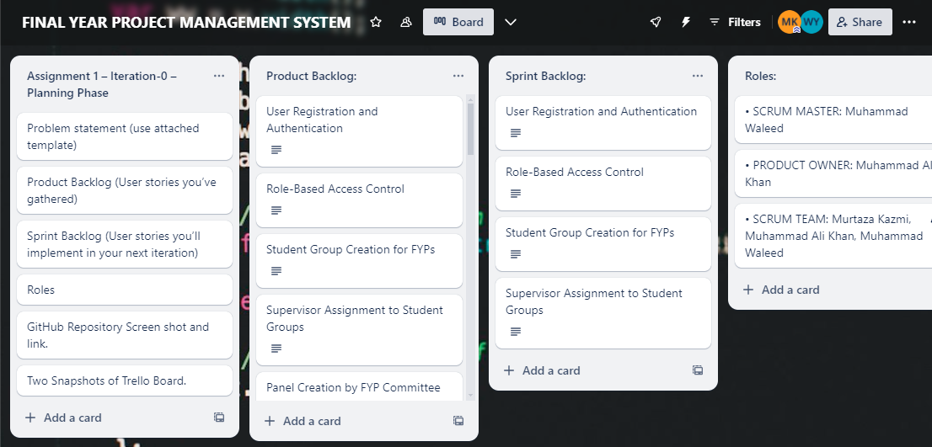

**2:**

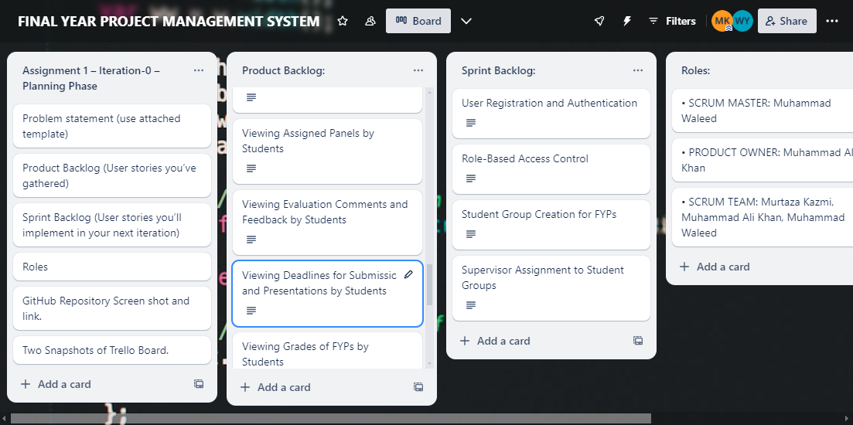

**GitHub Repository Screen shot and link:**

**1:**

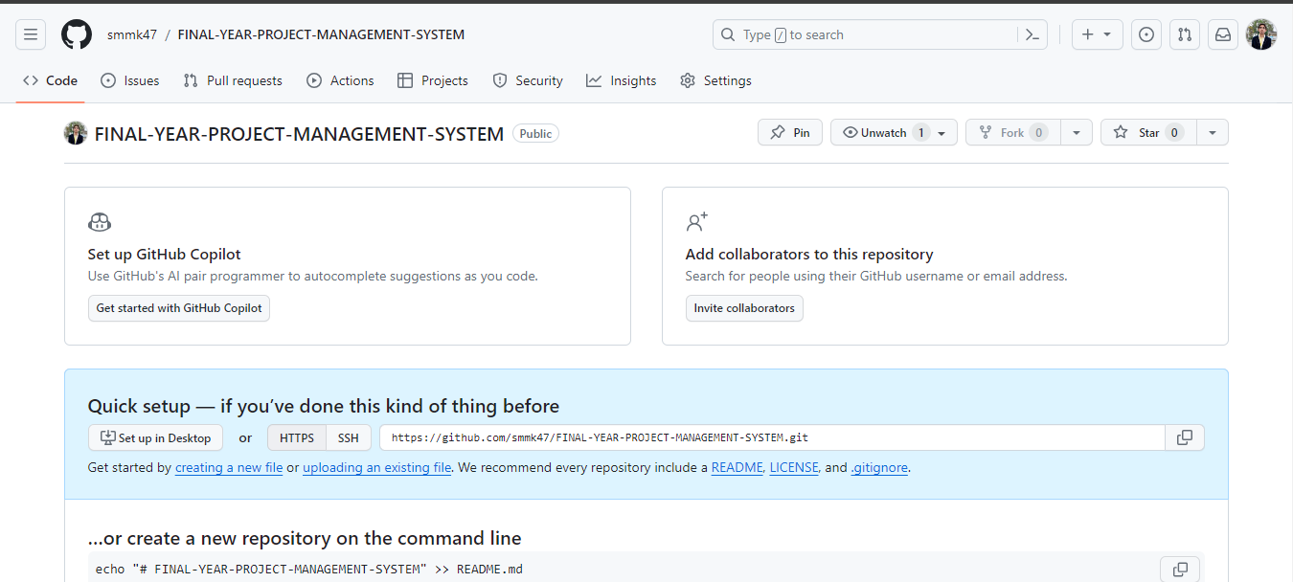

**2:** <https://github.com/smmk47/FINAL-YEAR-PROJECT-MANAGEMENT-SYSTEM>